CURRICULUMN VITAE

CHU KHAC HOAI DUONG |  |  |  | Chu 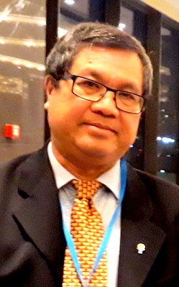
 | Partner, Duong & Partners Law Firm
 | 18/2 Thich Quang Duc, Ward 5, Phu Nhuan District, HCMC
 | 0903828321
 | duongchulawyer@gmail.com
 | Commercial Law
 | English, Russian, Vietnamese
Education
Qualifications |  | Bachelor
Major(s) |  | International Law
University(s) |  | Moscow State Institute of International Relations (MGIMO)
Work history
1986 - 1993 |  | Petechim Import and Export Company under the Ministry of Trade
Since 1989 |  | Lawyer of Ho Chi Minh City Law Association
Since 1992 |  | Arbitrator, VIAC
1993 - 2000 |  | Lawyer of Duong & Nghiem Law Firm
Since 2000 |  | Duong & Partners law firm

